**Operating System Interview Question**

**1. What is the goal of an operating system?**

The primary goal of an **Operating System (OS)** is to manage the computer’s hardware and software resources effectively, providing a stable and consistent environment for applications to run. Specific goals include:

* **Resource Management**: Manage CPU, memory, disk, and I/O devices.
* **Process Management**: Handle multitasking, process scheduling, and execution.
* **Memory Management**: Allocate memory to processes and ensure memory protection.
* **File System Management**: Manage data storage, retrieval, and file systems.
* **Security and Protection**: Ensure data integrity, restrict access, and protect the system from unauthorized access.
* **User Interface**: Provide an interface for users to interact with the system, whether through CLI (Command Line Interface) or GUI (Graphical User Interface).

**2. What is a kernel, and what is its function in an operating system?**

The **kernel** is the core part of an operating system that directly interacts with the hardware. It manages system resources and enables communication between hardware and software. Its main functions include:

* **Process Management**: Scheduling and controlling processes.
* **Memory Management**: Allocating and managing memory for running applications.
* **Device Management**: Communicating with and controlling hardware devices.
* **File System Management**: Managing files and directories.
* **System Security and Protection**: Enforcing permissions and access controls.

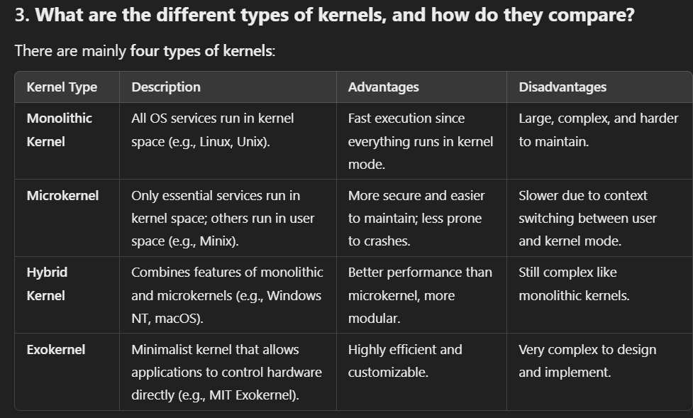

**4. What is the difference between a virtual address and a physical address?**

* **Virtual Address**: This is the address generated by the CPU during program execution. It is used by processes and mapped to a physical address by the Memory Management Unit (MMU).
* **Physical Address**: The actual address in the physical memory (RAM) where data and instructions are stored.

The OS and hardware (via MMU) translate virtual addresses to physical addresses, allowing programs to use more memory than is physically available (via virtual memory).

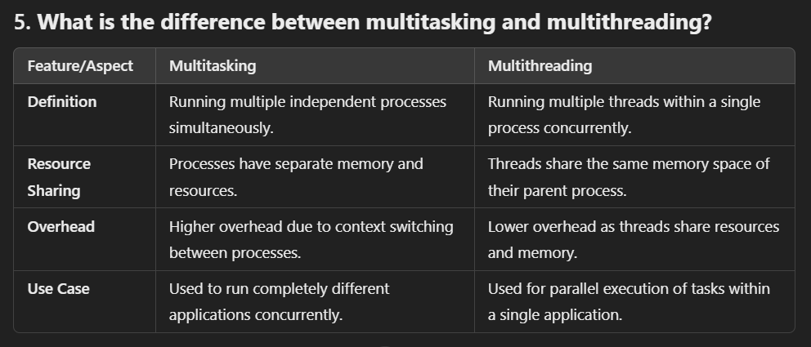

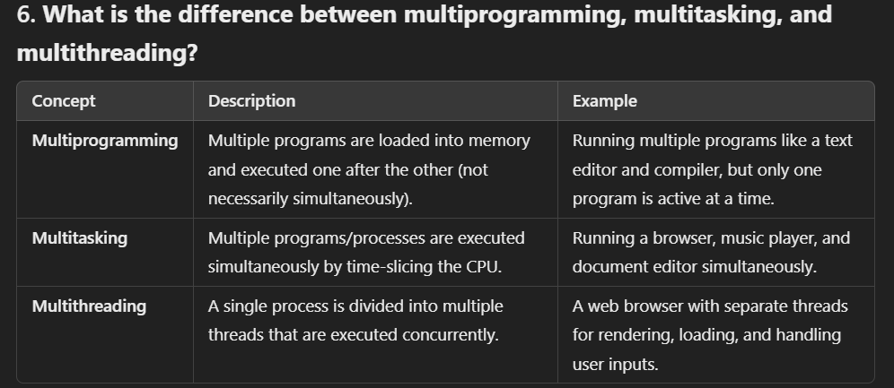

### **7. Explain the concept of context switching in threads vs processes.**

* **Context Switching in Threads**: When switching between threads within the same process, the system only needs to save and restore the state of registers and program counter. Since threads share the same memory space, it is faster.
* **Context Switching in Processes**: When switching between processes, the system must save and restore the entire process state, including registers, program counter, and memory (since each process has its own address space). This takes more time and is more resource-intensive than thread context switching.

**8. How does communication between processes (Inter-Process Communication) happen?**

Inter-Process Communication (IPC) allows processes to communicate and synchronize. Some common IPC mechanisms include:

* **Pipes**: Unidirectional communication channel between two related processes.
* **Message Queues**: Allows multiple processes to send and receive messages in a queue.
* **Shared Memory**: Multiple processes can access the same memory space, which requires synchronization to avoid data corruption.
* **Sockets**: Communication over a network between processes, often used in client-server architectures.
* **Semaphores**: Used to control access to shared resources to prevent race conditions.

**9. How does communication occur between user mode and kernel mode?**

Communication between **user mode** and **kernel mode** happens via **system calls**. A system call is a request from a user-mode process for the OS to perform a privileged task (like I/O operations, memory allocation, or process control). When a process makes a system call:

1. The process switches to kernel mode (a privileged mode).
2. The kernel executes the requested service.
3. The process switches back to user mode once the task is complete.

**10. What is a system call, and what are the different types of system calls?**

A **system call** is a mechanism used by user-mode programs to request services from the operating system's kernel.

Types of system calls include:

1. **Process Control**: For creating and terminating processes (e.g., fork(), exit()).
2. **File Management**: For reading, writing, and manipulating files (e.g., open(), close()).
3. **Device Management**: For interacting with hardware devices (e.g., ioctl()).
4. **Information Maintenance**: For getting or setting system information (e.g., getpid(), alarm()).
5. **Communication**: For data transfer between processes (e.g., pipe(), send(), recv()).

**11. What is the importance of system calls in an operating system?**

System calls are crucial because they provide an interface for user applications to interact with the operating system's kernel. Without system calls, user programs would not be able to access hardware or perform critical functions like file manipulation, process control, or communication. System calls help maintain the security and stability of the system by controlling access to hardware and resources.

**12. What happens when a computer is turned on?**

When a computer is powered on, the following steps occur:

1. **BIOS/UEFI Initialization**: The Basic Input/Output System (BIOS) or Unified Extensible Firmware Interface (UEFI) runs, performs a POST (Power-On Self-Test) to check hardware, and initializes system components.
2. **Bootloader Execution**: After POST, the BIOS/UEFI looks for the bootloader (e.g., GRUB) on the storage device.
3. **Kernel Loading**: The bootloader loads the OS kernel into memory.
4. **Kernel Initialization**: The kernel initializes system devices and drivers and starts system processes.
5. **User Interface Launch**: The operating system loads the user interface (CLI or GUI), allowing users to interact with the system.

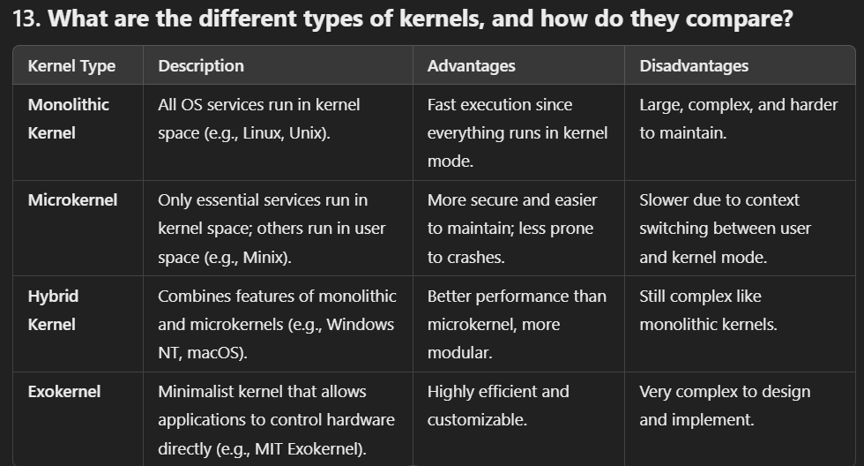

**Process and process Scheduling**

**1. Process:** Program (Compiled code which is ready to execute) under execution.

**Q2. What is PCB?**

A Process Control Block, or PCB, is a data structure used by the operating system to manage processes. Each process has its own PCB, which contains important information about that process, like:

1. **Process State:** Shows if the process is running, waiting, or terminated.
2. **Process ID:** A unique number that identifies the process.
3. **Program Counter:** Keeps track of the next instruction to execute.
4. **CPU Registers:** Stores temporary data for the process while it runs.
5. **Memory Information:** Details about how memory is allocated to the process.
6. **Scheduling Info:** Contains priority and scheduling data for the process.
7. **I/O Status:** Information about the input/output devices the process is using.

The PCB helps the OS manage processes efficiently. For example, when the OS switches from one process to another, it saves the current process's PCB and loads the next one, allowing it to continue from where it left off. In short, PCBs are essential for multitasking and resource management in an operating system.

**Q3. Draw diagram of process state and explain?**

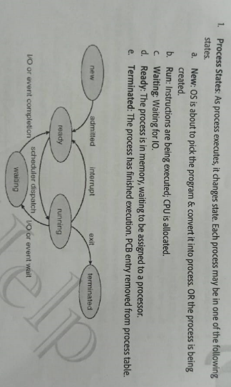

**Q4. Explain job queue**, **ready queue**, and **wait queue**:

**1. Job Queue**

* **Definition**: A queue holding all processes that are waiting to be loaded into main memory.
* **State**: Contains processes in the **New** state.
* **Managed By**: Long-term scheduler.

**2. Ready Queue**

* **Definition**: A queue for processes that are in main memory and ready to execute.
* **State**: Contains processes in the **Ready** state.
* **Managed By**: Short-term scheduler.

**3. Wait Queue**

* **Definition**: A queue for processes waiting for an event (e.g., I/O operation) to occur.
* **State**: Contains processes in the **Waiting** state.
* **Managed By**: Depends on the event they are waiting for.

**Note:** Number of process in the memory is said as degree of multi-programming.

**Q5. What Context Switching**

* **Definition**: Context switching is the process of saving the state of a currently running process and loading the state of another process. This allows the CPU to switch from one process to another.
* **Purpose**: It enables multitasking, allowing multiple processes to share a single CPU effectively.
* **Components Saved**: The operating system saves the process's:
  + Program Counter (PC)
  + CPU registers
  + Memory management information
  + Process state
* **When It Occurs**: Context switching occurs during:
  + Process preemption (time slice expiration)
  + I/O operations
  + Explicit calls to switch processes.

**Orphan Process :** A process that continues running after its parent has terminated.

**Cause**: Parent process exits before the child.

**Management**: Adopted by the init process (PID 1).

**Zombie Process:** A completed process that still has an entry in the process table.

**Cause**: The parent process hasn’t read the child's exit status.

**Management**: Remains until the parent calls wait().

**Impact**: Occupies space in the process table; can prevent new processes from being created if too many accumulate.

**Q6. What are the key terms related to process timing in CPU scheduling?**

**Throughput:** Refers to the number of processes the system can complete in a given time frame.

**Arrival Time (AT):** The time when a process enters the ready queue and is ready to start executing.

**Burst Time (BT):** The amount of CPU time required by a process for its execution.

**Turnaround Time (TAT):** The total time taken from when a process first enters the ready state until it completes. (TAT = Completion Time - Arrival Time)

**Wait Time (WT):** The total time a process spends waiting in the ready queue for the CPU. (WT = Turnaround Time - Burst Time)

**Response Time:** The time taken from when a process enters the ready queue to when it gets CPU time for the first time.

**Completion Time (CT):** The total time taken for a process to complete, from when it starts to when it finishes.

**Q7. What are the key differences between non-preemptive and preemptive scheduling, and their respective advantages and disadvantages?**

* **Non-preemptive scheduling:** Once a process is assigned to the CPU, it retains control until it either finishes or switches to a waiting state. This can cause issues such as:
  + **Starvation:** Longer processes may block shorter ones from getting CPU time.
  + **Lower CPU utilization:** The CPU may stay occupied by long-running processes for too long, preventing efficient use of resources.
* **Preemptive scheduling:** The OS can interrupt a process and take away the CPU, typically after a certain time quantum expires, and give it to another process in the ready queue. This offers several advantages:
  + **Reduced starvation:** Shorter processes can get CPU time more quickly, avoiding long waits.
  + **Improved CPU utilization:** The CPU is better shared among processes, leading to more efficient use of resources.

Q8. **What is process scheduling, how does the OS switch processes, and what are the goals of CPU scheduling?**

* **Process scheduling** is the core of multi-programming in operating systems. It manages how the OS switches the CPU between different processes, ensuring the system remains efficient and productive.
* **Process switching** happens when a process needs to wait, for example, during I/O operations or when its time quantum expires. The OS then assigns the CPU to another process, optimizing CPU usage.
* The **CPU scheduler** selects which process from the ready queue will execute next when the CPU becomes idle. This is typically handled by the Short-Term Scheduler (STS).

The main **goals of CPU scheduling** are:

* **Maximize CPU utilization**
* **Minimize Turnaround Time (TAT)**
* **Minimize wait time**
* **Minimize response time**
* **Maximize throughput** (number of processes completed per unit time)

### **Q7. Names of Process Scheduling Algorithms**

1. First-Come, First-Served (FCFS)
2. Shortest Job Next (SJN) or Shortest Job First (SJF)
3. Priority Scheduling
4. Round Robin (RR)
5. Multilevel Queue Scheduling
6. Multilevel Feedback Queue Scheduling
7. Shortest Remaining Time First (SRTF)
8. Rate Monotonic Scheduling (RMS)

**Q10: What is the Round Robin scheduling algorithm, how does it work, and what are its advantages and disadvantages?**  
**A:** Round Robin (RR) is a preemptive scheduling algorithm that assigns a fixed time unit (quantum) to each process in the ready queue. Processes are placed in the ready queue based on arrival time. The scheduler picks the first process, allows it to run for the time quantum, and then either completes it or preempts it to move it to the back of the queue. This cycle continues until all processes are completed.

**Advantages** include fairness, as all processes receive equal CPU time, and responsiveness, allowing shorter processes to complete quickly. **Disadvantages** are higher context-switching overhead and potentially increased waiting time for longer processes.

**Q11: What is Multilevel Queue Scheduling, how does it work, and what are its advantages and disadvantages?**  
**A:** Multilevel Queue Scheduling is a scheduling algorithm that divides the ready queue into multiple queues, each with different priority levels and scheduling policies, such as FCFS or Round Robin. Processes are assigned to specific queues based on their characteristics (e.g., interactive vs. batch processes). Each queue is scheduled independently, typically serving higher-priority queues first. Once a queue is empty, the scheduler may proceed to the next queue.

**Advantages** include flexibility in handling different types of processes and improved performance for specific workloads. **Disadvantages** involve the complexity of managing multiple queues and the potential for starvation of processes in lower-priority queues.

**Q12: What is Multilevel Feedback Queue Scheduling, how does it work, and what are its advantages and disadvantages?**  
**A:** Multilevel Feedback Queue Scheduling is an advanced version of multilevel queue scheduling that allows processes to move between queues based on their behavior and requirements, optimizing CPU utilization and responsiveness. Processes start in the highest-priority queue and can move down to lower-priority queues if they exceed their time quantum or wait too long. Conversely, if a process uses less CPU time than expected, it can be moved to a higher-priority queue, allowing for dynamic adjustments that improve overall system performance.

**Advantages** include better CPU utilization, responsiveness, and adaptability to different process behaviors. **Disadvantages** involve the complexity of implementation and the potential for starvation if not managed properly.

**Q13: What is the convoy effect, what causes it, and how can it be prevented?**  
**A:** The convoy effect occurs when shorter processes are delayed because they have to wait for long-running processes to complete, leading to increased waiting times, reduced system throughput, and poor resource utilization. It is caused by scheduling scenarios where a long process blocks shorter ones. To prevent this effect, operating systems can use preemptive scheduling to allow shorter tasks to run first or implement algorithms like Shortest Job First (SJF) or Round Robin (RR).

**Concurrency/ critical section/ synchronization/Deadlock**

**1. What is a Critical Section?**

A **critical section** is a portion of code where a shared resource (like data or a variable) is accessed or modified. Since multiple processes or threads may try to access the same resource simultaneously, ensuring safe access is crucial to avoid conflicts.

**2. What problem does the Critical Section cause?**

The critical section can cause the **"Race Condition"** problem, where the outcome of processes or threads depends on the order in which they access the shared resource. If two processes or threads modify the resource at the same time, it can lead to inconsistent or incorrect data.

**3. What are the conditions that a solution to the Critical Section Problem must satisfy?**

To safely manage the critical section, a solution must meet three requirements, known as **mutual exclusion**, **progress**, and **bounded waiting**:

* **Mutual Exclusion**: Only one process or thread should access the critical section at a time.
* **Progress**: If no process is in the critical section, others waiting to enter should be able to do so in a reasonable amount of time.
* **Bounded Waiting**: There must be a limit on how long a process waits before entering the critical section.

**4. How can we resolve the Critical Section Problem?**

There are several mechanisms to handle the critical section problem:

* **Locks/Mutex**: A lock is a mechanism that ensures that only one thread or process can access the critical section at any time.
* **Semaphores**: A semaphore is a synchronization tool used to control access to the critical section using signaling between processes.
* **Monitors**: A higher-level abstraction that allows safe access to shared resources by ensuring that only one process is executing the critical section.
* **Peterson’s Algorithm**: A software-based solution for two-process systems, ensuring mutual exclusion and avoiding race conditions.
* **Hardware Solutions**: Some systems use hardware instructions like **Test-and-Set** or **Compare-and-Swap** to ensure mutual exclusion.

What are the necessary conditions which can lead to a deadlock in a system?

Mutual Exclusion: There is a resource that cannot be shared.

Hold and Wait: A process is holding at least one resource and waiting for another resource, which is with some other process.

No Preemption: The operating system is not allowed to take a resource back from a process until the process gives it back.

Circular Wait: A set of processes waiting for each other in circular form.

**What are the issues related to concurrency?**

* **Non-atomic**: Operations that are non-atomic but interruptible by multiple processes can cause problems.
* [Race conditions](https://www.geeksforgeeks.org/race-condition-vulnerability/): A race condition occurs of the outcome depends on which of several processes gets to a point first.
* **Blocking**: Processes can block waiting for resources. A process could be blocked for a long period of time waiting for input from a terminal. If the process is required to periodically update some data, this would be very undesirable.
* [Starvation](https://www.geeksforgeeks.org/starvation-and-aging-in-operating-systems/): It occurs when a process does not obtain service to progress.
* [Deadlock](https://www.geeksforgeeks.org/introduction-of-deadlock-in-operating-system/): It occurs when two processes are blocked and hence neither can proceed to execute  
  Q. dis adv of mutex  
  seamophore  
  condition variable

**Deadlock**

1. **What is a deadlock?**  
   A deadlock is a situation in operating systems where a set of processes becomes stuck because each process is waiting for a resource that another process in the set holds, and none of them can proceed.
2. **What are the necessary conditions for a deadlock to occur?**  
   Four conditions must hold simultaneously for a deadlock to occur:
   * **Mutual Exclusion:** Only one process can use a resource at a time.
   * **Hold and Wait:** A process holding at least one resource is waiting for additional resources held by other processes.
   * **No Preemption:** Resources cannot be forcibly taken from a process; they must be released voluntarily.
   * **Circular Wait:** A circular chain of processes exists, where each process is waiting for a resource held by the next process in the chain.

**Q3. What are methods for handling deadlocks in operating systems?.**

**1. Deadlock Prevention:**Deadlock prevention ensures that the system never allows deadlock conditions to occur by violating at least one of the four necessary conditions (mutual exclusion, hold and wait, no preemption, and circular wait).

* **Eliminate Mutual Exclusion**: Make resources sharable so that multiple processes can access them at the same time (not possible for all resources, such as printers).
* **Eliminate Hold and Wait**: Require processes to request all needed resources at once. A process will not hold onto any resources while waiting for more.
* **Eliminate No Preemption**: Allow preemption of resources. If a process is holding a resource and requests another, the held resource is taken away and given to another process.
* **Eliminate Circular Wait**: Impose a total ordering on resource acquisition. Processes must request resources in a specific, pre-defined order to prevent circular waits.

**2. Deadlock Avoidance:**Deadlock avoidance requires the system to make decisions dynamically about resource allocation and ensure that the system never enters an unsafe state where deadlock is possible.

* **Banker's Algorithm**: This is the most well-known deadlock avoidance algorithm. The system checks if granting a resource to a process leads to a safe state, meaning there is a sequence of processes that can run to completion. If granting a resource results in an unsafe state, the system denies the request.

The basic steps in the Banker's Algorithm:

1. Evaluate the current available resources.
2. Simulate resource allocation.
3. Check if the system remains in a safe state.
4. Approve or deny the request based on safety.

**3. Deadlock Detection and Recovery:**This method allows deadlock to occur but uses a mechanism to detect it and then recover from it.

* **Detection Algorithm**: The system periodically runs an algorithm (e.g., using a resource allocation graph or wait-for graph) to check for cycles, which would indicate the presence of deadlock.
* **Recovery Methods**:
  + **Process Termination**: Terminate one or more processes involved in the deadlock to break the cycle. This can be done:
    - By terminating all deadlocked processes (drastic solution).
    - By terminating one process at a time and checking if the deadlock is resolved.
  + **Resource Preemption**: Temporarily take resources from some processes to free up resources for others. This requires a rollback mechanism to restore the state of preempted processes.

**4. Deadlock Ignorance (Ostrich Algorithm):**This method simply ignores the possibility of deadlocks. It is used when the occurrence of deadlocks is very rare, and the cost of handling deadlocks outweighs the benefits.

* **Example**: Many modern operating systems like Windows and Unix use the deadlock ignorance approach, assuming that deadlocks occur so rarely that it is better to restart the system if they happen rather than spend resources trying to prevent or detect them.

**4.Explain the differences between deadlock, starvation, and livelock.**

* + **Deadlock** occurs when processes are stuck waiting for resources in a cycle and can never proceed.
  + **Starvation** happens when a process waits indefinitely because other processes are continuously prioritized over it.
  + **Livelock** occurs when processes are active and keep changing states but do not make any progress because they continuously respond to each other in a way that prevents completion.

**Advanced Questions:**

**5.Explain the Deadlock Detection Algorithm. How can a system detect a deadlock?**  
The system maintains a resource allocation graph (or a matrix) to track which processes hold which resources and which processes are waiting. The system periodically checks for cycles in the resource allocation graph. If a cycle is found, the system detects that a deadlock has occurred.

**6.What is the difference between deadlock prevention and deadlock avoidance?**

* + **Deadlock Prevention:** It ensures that at least one of the necessary conditions for deadlock is always violated, so deadlock cannot occur (e.g., disabling mutual exclusion or circular wait).
  + **Deadlock Avoidance:** The system makes dynamic decisions during runtime to ensure that it never enters an unsafe state where deadlock is possible (e.g., using the Banker's Algorithm).

1. **How does the Banker's Algorithm prevent deadlock? Can you describe the steps involved in it?**  
   The Banker's Algorithm works by simulating the allocation of resources and ensuring that there is always a safe sequence of execution for processes. It checks if the system can still allocate resources such that every process can finish without entering a deadlock state. If it cannot find a safe state, it denies resource allocation.
2. **How can you break the hold-and-wait condition to prevent deadlock?**  
   To break the hold-and-wait condition, a system can ensure that a process must request and acquire all the resources it needs at once before it starts execution. This way, no process will hold some resources while waiting for others.
3. **What strategies can an operating system use to recover from deadlock once it is detected?**
   * **Resource Preemption:** Temporarily take resources from some processes to break the deadlock.
   * **Process Termination:** Kill one or more processes involved in the deadlock to release resources.
   * **Rollback:** Rollback the processes to an earlier state before they requested resources that caused the deadlock.

**Scenario-Based Questions:**

1. **Consider a system where a deadlock has occurred. How would you resolve it?**  
   First, I would detect the deadlock using a detection algorithm. Then, I would either:
   * Preempt resources from some processes,
   * Terminate one or more processes involved in the deadlock, or
   * Rollback processes to break the deadlock cycle.
2. **Suppose a system allows for preemption. How would you use this to avoid deadlock?**  
   In a system with preemption, if a process holds a resource and is waiting for another resource, the operating system can forcibly take away the held resource and give it to another process, effectively preventing the hold-and-wait condition that leads to deadlock.
3. **Given a resource allocation graph, can you determine whether a deadlock has occurred?**  
   Yes, if the resource allocation graph has a cycle, and all the resources in that cycle are involved in the circular wait, then a deadlock has occurred. If no cycle is detected, there is no deadlock.
4. **How does the concept of a safe state in Banker's Algorithm help avoid deadlock?**  
   A safe state means that the system can allocate resources in such a way that all processes can complete their execution without entering a deadlock. Banker's Algorithm avoids deadlock by ensuring the system never enters an unsafe state where deadlock is possible.
5. **Describe a real-life analogy of deadlock. How would you apply deadlock prevention techniques to solve it?**  
   A real-life example of deadlock could be a situation where four cars are stopped at a four-way intersection, and each car is waiting for the other to move first.  
   **Solution (Deadlock Prevention Techniques):**
   * **Mutual Exclusion:** The road can be made one-way, so only one car can pass.
   * **Hold and Wait:** Require cars to wait until they can pass through without stopping.
   * **Circular Wait:** Enforce rules that cars take turns moving in a fixed order (e.g., clockwise).

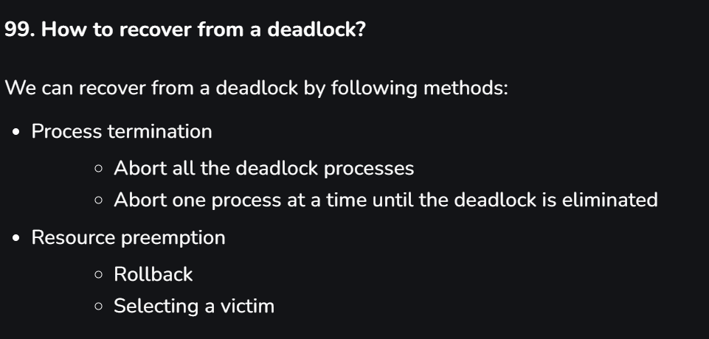

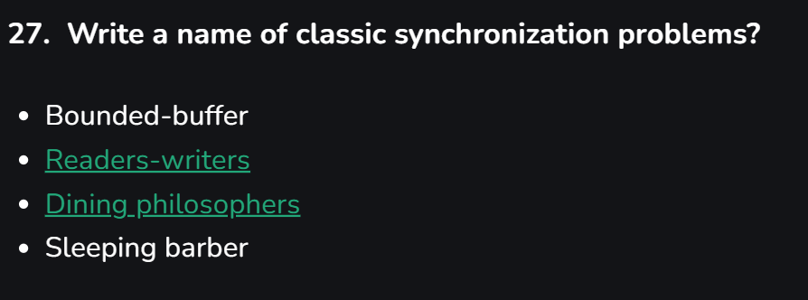

**Disk Scheduling**

**1.Architecture of disk?**

|  |  |
| --- | --- |
|  |  |

**Seek time**: It is the time it takes for the disk's read/write head to move to the track where the data is stored.

**2.Disk scheduling algorithm?(**Focus on reducing seek time,increasing throput , reduce latency**)**

Ans: The disk management algorithms in an operating system (OS) are responsible for managing how data is read from and written to the disk. Some common disk scheduling algorithms include:

1. **First-Come, First-Served (FCFS)**: Processes disk requests in the order they arrive.
2. **Shortest Seek Time First (SSTF)**: Selects the disk I/O request that requires the least movement of the disk arm from its current position.
3. **SCAN (Elevator Algorithm)**: The disk arm moves in one direction servicing requests until it reaches the end, then reverses direction and services requests on the way back.
4. **C-SCAN (Circular SCAN)**: Similar to SCAN, but the disk arm goes to the end and then jumps back to the beginning without servicing requests on the return.
5. **LOOK and C-LOOK**: Variants of SCAN and C-SCAN, where the disk arm only goes as far as the last request in each direction before reversing.
6. **Ex**: **98, 183, 37, 122, 14, 124, 65, 67**.

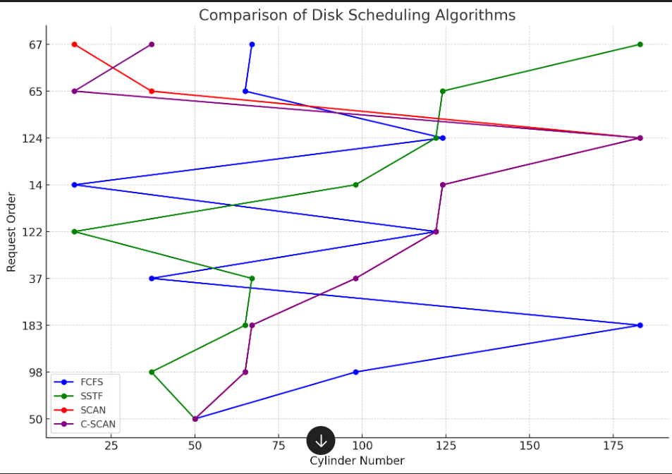

2.**What is Disk Scheduling?**

**Disk scheduling** is the method used by operating systems to determine the order in which I/O requests to a disk are processed. It is crucial for managing read and write requests efficiently, especially in environments where multiple processes may require disk access simultaneously.

**Purpose of Disk Scheduling in Operating Systems**

The primary purposes of disk scheduling include:

1. **Optimizing Disk Utilization:** Ensuring that the disk is used effectively by minimizing idle time.
2. **Maximizing Throughput:** Increasing the number of requests serviced within a given timeframe.
3. **Minimizing Latency:** Reducing the average wait time for requests, enhancing user experience.
4. **Ensuring Fairness:** Guaranteeing that all processes have equitable access to disk resources, preventing starvation.

3. **How do you Analyze the Performance of Disk Scheduling Algorithms?**

To analyze disk scheduling algorithms, several metrics can be employed:

1. **Average Wait Time:** The mean time a request spends waiting in the queue.
2. **Average Turnaround Time:** The total time taken from the request submission to its completion, encompassing wait and service times.
3. **Throughput:** The number of requests processed in a given period (requests per second).
4. **Response Time:** The time taken to start processing a request after it has been submitted.
5. **Utilization:** The proportion of time the disk is actively servicing requests versus being idle.

**4.What are the Trade-offs in Disk Scheduling Algorithms?**

When evaluating disk scheduling algorithms, there are key trade-offs:

**1.Throughput vs. Latency(**Latency refers to the delay before a transfer of data begins**):**

Some algorithms (e.g., SSTF) may reduce latency but could negatively impact throughput if they prioritize short requests at the expense of distant ones.

**2Fairness vs. Efficiency:**

Algorithms ensuring fairness may lead to inefficiencies, such as longer wait times for certain requests, while those focused solely on throughput could cause starvation for less prioritized requests.

5. **What Is Disk Fragmentation and Its Impact on Scheduling?**

**Disk Fragmentation** refers to the condition where data is stored non-contiguously across the disk, leading to inefficient disk utilization. Its impact on scheduling includes:

**Increased Seek Time:** Fragmented files require the disk head to move to multiple locations, increasing the time taken to access data.

**Decreased Throughput:** More time spent seeking means less time spent transferring data, reducing overall throughput.

**Memory Management**

**Q.** **What is memory management and its Goal ?**

**a) Contiguous Memory allocation (paging, segmentation)**

Contiguous memory allocation is a memory management technique in which a single contiguous block of memory is allocated to a process. This approach is straightforward but can lead to problems such as fragmentation. Contiguous memory allocation can be divided into two main categories: **fixed partitioning** and **dynamic partitioning**.

**1. Fixed Partitioning**

In fixed partitioning, the memory is divided into a set of fixed-size partitions(may same or different). Each partition can hold one process, and the size of these partitions is determined before the system runs.

**Advantages:**

* **Simplicity**: Easy to implement and manage since the number of partitions and their sizes are predefined.
* **Fast Allocation**: Allocation and deallocation of memory are quick, as they involve simple calculations.

**Disadvantages:**

* **Limited Flexibility**: Since partitions are of fixed size, processes that require memory larger than a partition cannot be accommodated, and smaller processes may leave unused space.
* **Internal Fragmentation**: If a process doesn’t fully utilize the allocated partition, then unused memory within that partition is wasted. For example, if a partition is 100 KB and a process requires only 80 KB, there is 20 KB of internal fragmentation.
* **External Fragmentation**: The total unused space of various partition cannot be used to load the process even though there is space available but not in contiguous form.
* **Low degree of multiprogramming**:

**2.Dynamic Partitioning:**

**Dynamic Partitioning** is a memory management technique where the operating system allocates memory to processes in variable-sized partitions based on their actual size requirements during process loading. Unlike fixed partitioning, where memory blocks are predefined.

**Advantages:**

1. **Better Memory Utilization**: Memory is allocated based on the process's exact needs, reducing internal fragmentation and minimizing wasted space.
2. **Flexibility**: Partitions are created dynamically, accommodating varying process sizes and allowing better adaptation to different workloads.
3. **Efficient Use of Resources**: Allows processes to use available memory more efficiently, especially when memory demand fluctuates.

**Disadvantages:**

1. **External Fragmentation**: Over time, free memory blocks become scattered, making it harder to find contiguous space for larger processes.
2. **Complex Management**: Requires more sophisticated algorithms to track free and used memory, increasing the complexity of memory management.
3. **Slow Allocation**: Searching for the best fit partition can take time, leading to slower memory allocation compared to fixed partitioning.

**Q1: What problem does dynamic partitioning suffer from, and how does compaction address this issue?**

Dynamic partitioning suffers from external fragmentation. Compaction is a technique used to minimize this problem by making all free partitions contiguous and merging the loaded partitions. However, compaction decreases system efficiency, as transferring free spaces from several places to a single location is time-consuming.

**Q2: How does the Operating System manage free space (due to external fragmantation) and allocate memory to processes?**

**A2:** In an Operating System, free space is represented by a free list, typically using a linked-list data structure. The OS allocates memory to processes using various algorithms such as First Fit, Next Fit, Best Fit, and Worst Fit.

* **First Fit** allocates the first hole large enough to meet the process’s needs, offering simplicity and fast time complexity.
* **Next Fit** is similar but starts the search from the last allocated hole.
* **Best Fit** allocates the smallest sufficient hole, reducing internal fragmentation but potentially increasing external fragmentation due to many small holes, making it slower.
* **Worst Fit** allocates the largest hole, which can leave bigger holes for future allocations but is also slow due to requiring a full iteration through the list of free holes.

**b) Non-Contiguous Memory allocation (paging, segmentation).**

**1.Paging (**it help to over- come the problem of external fragmentation of dynamic partitioning**):**

**What is Paging?**

**Paging** is a memory management technique in which a process's memory is divided into fixed-size blocks called *pages*, while physical memory (RAM) is divided into equally sized blocks called *frames*. The operating system manages the mapping between the process's pages and the available frames in physical memory.

* **Pages**: Logical blocks of memory (part of a process).
* **Frames**: Physical blocks of memory (part of RAM).

Instead of requiring processes to have contiguous memory, paging allows processes to be loaded into non-contiguous memory frames, helping to efficiently utilize available memory.

**Why Use Paging?**

Paging is used to solve the problem of **external fragmentation** and make better use of memory. In dynamic or fixed partitioning systems, it can be hard to find contiguous blocks of memory as processes are loaded and removed, leading to wasted space between memory blocks. Paging avoids this by allowing processes to be spread across non-contiguous memory locations.

**When to Use Paging?**

Paging is useful when:

* You want to efficiently manage memory without worrying about contiguous allocations.
* You need to support **virtual memory**, where processes can use more memory than is physically available in RAM by swapping pages between memory and disk.
* You want to minimize fragmentation and improve system performance.

**How to Use Paging?**

Paging is handled by the operating system and involves several steps:

1. **Divide Process into Pages**: The logical address space of a process is divided into fixed-size pages (e.g., 4 KB).
2. **Divide Physical Memory into Frames**: Physical memory is divided into frames of the same size as the pages.
3. **Page Table Creation**: The operating system creates a *page table* for each process. The page table keeps track of which page is stored in which frame of physical memory.
4. **Address Translation**: The CPU generates logical addresses, which are then split into:
   * **Page number**: Index of the page in the page table.
   * **Offset**: The actual address within the page.

The operating system uses the page table to map the page number to the corresponding frame number in physical memory. The offset is added to the frame address to get the actual physical address.

1. **Page Replacement (if needed)**: If all frames are full and a new page needs to be loaded, the operating system may swap out an old page from memory (to disk) and bring in the new one, following a page replacement algorithm (e.g., FIFO, LRU).

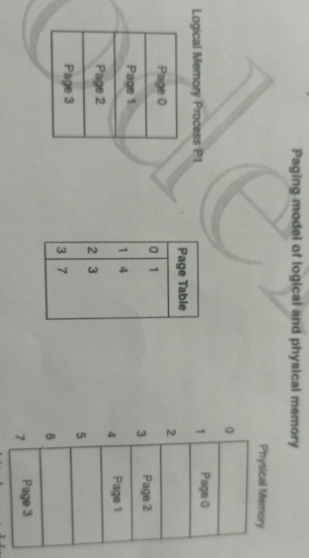

1. Page table is stored in main memory at the time of process creation and its base address is stored **in process control block**(pcb).
2. **Page table base register** PTBR is used to changing page table during context switching.
3. The **Translation Lookaside Buffer (TLB)** is a cache that stores recent translations of virtual addresses to physical addresses in systems using paging. It speeds up the address translation process by checking for translations before consulting the slower page table. TLBs significantly enhance system performance by reducing latency and minimizing memory access times.

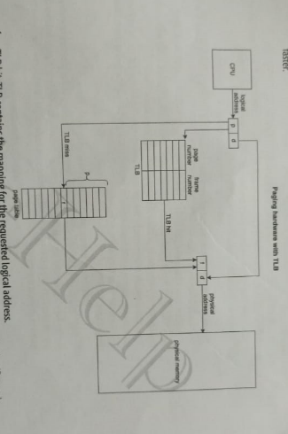

**Advantages of Paging:**

1. **No External Fragmentation**: Because pages can be placed in any available frame, memory is used more efficiently.
2. **Simplifies Memory Allocation**: The system doesn't need to find contiguous memory, just available frames.
3. **Supports Virtual Memory**: Processes can use more memory than is physically available by paging out to disk.

**Disadvantages of Paging:**

1. **Internal Fragmentation**: A process might not completely fill a page, leading to some wasted space within pages.
2. **Overhead**: Page tables need to be maintained, and address translation adds some overhead.
3. **Page Faults**: If a required page is not in memory, it results in a page fault, which can slow down performance if paging to disk occurs frequently.

**2.Segmentation**

1. **Definition**: Segmentation is a memory management technique that divides memory into variable-sized segments based on the logical divisions of a program.
2. **Structure**:
   * Memory is divided into **segments** that can represent different logical units of a program, such as functions, arrays, or objects.
   * Each segment can be of different lengths.
3. **Address Translation**:
   * A logical address consists of a **segment number** and an **offset** within that segment.
   * A segment table maps segment numbers to physical memory addresses.
4. **Fragmentation**:
   * Segmentation can lead to **external fragmentation** since segments are of variable size and may not fit into available memory spaces.
   * Internal fragmentation is less of an issue compared to paging.
5. **Advantages**:
   * More intuitive as it aligns with the logical structure of programs.
   * Facilitates protection and sharing of segments among processes.
6. **Disadvantages**:
   * Can suffer from external fragmentation.
   * Managing variable-sized segments can be more complex.

Q **Segmentation VS Paging**

| **Feature** | **Segmentation** | **Paging** |
| --- | --- | --- |
| **Definition** | Divides memory into variable-sized segments based on logical divisions of a program. | Divides memory into fixed-size pages (virtual memory) and frames (physical memory). |
| **Structure** | Memory segments can vary in size (e.g., functions, arrays). | Memory is divided into equal-sized pages (e.g., 4 KB). |
| **Address Format** | Logical address consists of a **segment number** and an **offset**. | Logical address consists of a **page number** and an **offset**. |
| **Translation Method** | Uses a segment table to map segment numbers to physical addresses. | Uses a page table to map page numbers to frame numbers. |
| **Fragmentation Type** | Can lead to **external fragmentation** (variable sizes). | Can lead to **internal fragmentation** (last page may be partially used). |
| **Memory Management** | More intuitive, aligning with the logical structure of programs. | Simplifies memory management and eliminates external fragmentation. |
| **Use Case** | Suitable for programs with logically distinct sections. | Suitable for processes needing fixed-size blocks for efficient memory use. |

**Virtual Memory/ Page fault/ Demand Paging**

**1: What is virtual memory, and when is it used? What are its advantages and disadvantages?**

**A1:**  
**Virtual memory** is a memory management technique that allows the system to use more memory than what is physically available with help of hard disk (known as the swap space or page file) to act as additional RAM. It enables large programs or multiple programs to run simultaneously without being constrained by the physical RAM.

**When it is used:**  
Virtual memory is used when a system has insufficient physical RAM to handle the currently running processes. It allows the operating system to swap data between physical memory and disk storage, creating the illusion of a larger memory space.

**Advantages:**

* **Increased memory capacity:** Virtual memory extends the usable memory beyond the limits of physical RAM.
* **Efficient multitasking:** It allows multiple applications to run simultaneously by swapping data between RAM and disk.
* **Isolation:** Each process can be isolated in its own virtual memory space, improving security and stability.

**Disadvantages:**

* **Slower performance:** Accessing data from disk (swap space) is much slower than accessing RAM, which can lead to performance degradation when extensive swapping occurs (thrashing).
* **Disk space usage:** Virtual memory uses disk space, and if too much is used, it can reduce the available storage.
* **Complex management:** The operating system must manage page swapping, which adds complexity and overhead.

**Q2: How is virtual memory implemented?**

**A2:**  
Virtual memory is implemented by dividing the program's memory into **pages** (fixed-size blocks). These pages can be loaded into **page frames** in physical RAM as needed. The **paging mechanism** allows the OS to map virtual addresses to physical addresses.

When the system runs out of physical memory, the OS swaps some of the pages in RAM to the hard disk's swap space. If the swapped-out pages are needed again, the OS retrieves them from the disk.

**Q3: What is demand paging?**

**A3:**  
**Demand paging** is a technique where pages are loaded into memory only when they are required by the program, rather than loading the entire program into memory at once. If a program accesses a page that is not currently in memory, a **page fault** occurs, and the OS loads the needed page from disk to memory.

**Q4: What is a page fault?**

**A4:**  
A **page fault** occurs when a program tries to access a page that is not currently in physical memory. When a page fault happens, the operating system retrieves the requested page from the disk (swap space) and loads it into RAM. This process can slow down performance because accessing data from disk is much slower than accessing it from RAM.

Page faults are common in demand paging systems, but excessive page faults (thrashing) can degrade system performance if the system constantly has to swap pages between memory and disk.

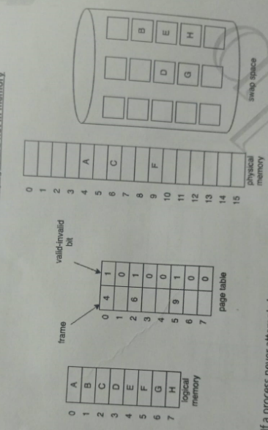

**Q1: What is a page replacement algorithm, and when is it used?**

**A1:**  
A **page replacement algorithm** is used in a virtual memory system when there is no free frame available in the physical memory (RAM) to load a new page. The algorithm decides which page currently in memory should be replaced (swapped out to disk) to make space for the new page that needs to be loaded. It is used in systems with **demand paging** when a **page fault** occurs, and all physical memory is already occupied.

Page replacement algorithms aim to minimize the number of page faults by making intelligent decisions about which pages to replace.

**Q2: What are common page replacement algorithms?**  
The most common page replacement algorithms include:

**1. FIFO (First-In-First-Out)**

* **Description:** The oldest page in memory (the one loaded first) is replaced.
* **How it works:** Pages are stored in a queue, and the page that has been in memory the longest is swapped out.
* **Advantages:** Simple to implement.
* **Disadvantages:** It can replace a page that is still heavily used, leading to inefficient memory usage.

**2. LRU (Least Recently Used)**

* **Description:** The page that has not been used for the longest period of time is replaced.
* **How it works:** The system tracks the order of page accesses, and the least recently accessed page is replaced.
* **Advantages:** More accurate because it reflects the actual usage pattern of pages.
* **Disadvantages:** Maintaining a record of access times for all pages increases overhead.

**3. Optimal Page Replacement (OPT)**

* **Description:** This algorithm replaces the page that will not be used for the longest period in the future.
* **How it works:** It looks into the future to determine which page can stay in memory the longest before being accessed again.
* **Advantages:** Provides the lowest possible number of page faults.
* **Disadvantages:** Impossible to implement in real systems because the future cannot be predicted.

**4. LFU (Least Frequently Used)**

* **Description:** The page with the lowest frequency of usage is replaced.
* **How it works:** The system keeps a count of how often each page is accessed, and the page with the lowest count is replaced.
* **Advantages:** Pages that are frequently used are less likely to be replaced.
* **Disadvantages:** It can perform poorly when a page was used heavily in the past but is no longer needed.

**Q3: What is thrashing?**  
**Thrashing** occurs when the system spends more time swapping pages in and out of memory than executing processes. This happens when the system is overloaded, and there are too many page faults because there isn't enough physical memory to hold the working set of pages for active processes. As a result, performance severely degrades, and the system becomes inefficient.

**Q4: What is Belady’s Anomaly?**

In most cases, increasing the number of page frames should reduce the number of page faults, but in Belady’s Anomaly, the opposite happens due to the poor decision-making of the **FIFO** algorithm.This anomaly does not occur with algorithms like **LRU** and **Optimal Page Replacement**.

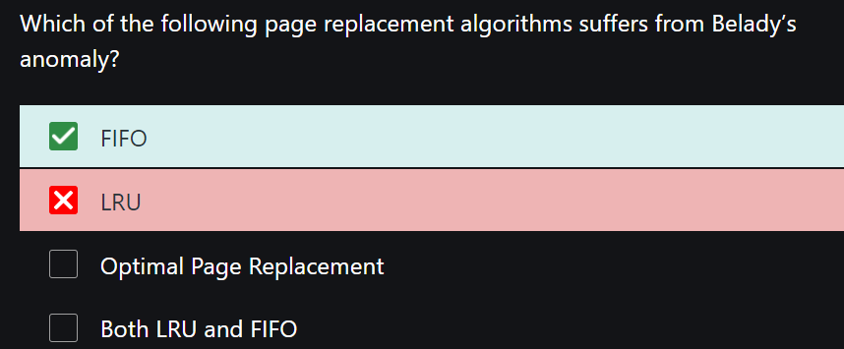

**Q2. Use of register and cache memory**

**Q3. Logical vs physical address?**